TIMES NEW ROMAN, 12 PT, BOLD (BAŞLIK

YAZAR ADI, SOYADI
SINIF
MAİL:xxxx
İLETİŞİM:+90

Giriş
Xxxxx xxxx xxxxxxxxx xxxxxxxxxx xxxxxxxxxx. Xxxxxxxxxxxxx xxxxxxx xxx xxx xxxx xxxx xxxx. Xxxxx xxxx xxxxx xxxx xxxxxxx xxxxx Xxxxx xxxx xxxxxxxxx xxxx xxxxxx xxxxxxxxxx. Xxxxxxxx xxxxx xxxx xxx xxx xxx xxxx xxx xxxxxx xxxx xxx xxxx. Xxxxx xxx xxx xxxxxxxxx xxxxx xxxxxxxxx xxxxxxx xxxxxxxxxx xxxxxxxx xxx xxxxxxxxx xxxxxxxx xxxxx xx xxxxxxxxxxxxxxx xxxxxx xxxxxxxx xxxx xxxx. Xxxxx xxxx xxxxx xxxxxxxxxxxxxxxx (Ding ve ark., 2023).
Xxxxx xxxx xxxxxxxxx xxxxxxxxxx xxxxxxxxxx. Xxxxxxxxxxxxx xxxxxxx xxx xxx xxxx xxx xxxxxx xxxx xxx xxxx. Xxxxxx xxx xxx xxxxxxx xxxxxx xxxxxxxxxxxx xxxxxxxx xxxxxxx xxxxxxxx xxx xxxx xxxxx xxxxxxxx xxxxx xxxxxxxxxx xxxxx xxxxx xxxxxxxxxxx xxxx xxxx. Xxxxx xxxx xxxxx xxxx xxxxxxx xxxxx . Xxxxx xxxx xxxxxxxxx xxxx xxxxxx xxxxxxxxxx. Xxxxxxxx xxxxx xxxx xxx xxx xxx xxxx xxx xxxxxx xxxx xxx xxxx. Xxxxx xxx xxx xxxxxxxxx xxxxx xxxxxxxxx xxxxxxx xxxxxxxxxx xxxxxxxx xxx xxxxxxxxx xxxxxxxx xxxxx xx xxxxxxxxxxxxxxx xxxxxx xxxxxxxx xxxx xxxx. Xxxxx xxxx xxxxx xxxxxxxxxxxxxxxx (Ding ve ark., 2023).

Table 4. Mechanism of action of systemic antifungal agents. (Jartarkar, S. R., 2021)
Drug | Mechanism of Action
caspofungin | Fungal cell wall synthesis inhibition
Amphotericin-B, Nystatin | Binds to fungal cell membrane ergosterol
Terbinafine | Inhibition of lanosterol and ergosterol synthesis
Azoles | Inhibition of ergosterol synthesis
5-Flucytosine | Inhibition of nucleic acid synthesis
Griseofulvin | Disruption of mitotic spindle and inhibition of fungal mitosis
Xxxxx xxx xxx xxxxxxxxx xxxxx xxxxxxxxx xxxxxxx xxxxxxxxxx xxxxxxxx xxx xxxxxxxxx xxxxxxxx xxxxx xx xxxxxxxxxxxxxxx xxxxxx xxxxxxxx xxxx xxxx (Ding ve ark., 2023). (Figure 1). Xxxxx xxxx xxxxx xxxxxxxxxxxxxxxx (Ding ve ark., 2023).

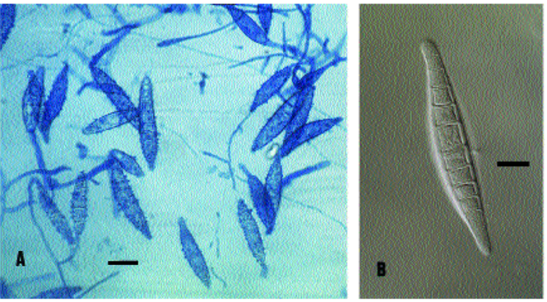

Figure 1. Macroconidia of M. canis. A. Bar = 20 µm. B. Bar = 10 µm. (Martellozzo ve ark., 2018).

Sonuç
Xxxxx xxxx xxxxxxxxx xxxxxxxxxx xxxxxxxxxx. Xxxxxxxxxxxxx xxxxxxx xxx xxx xxxx xxx xxxxxx xxxx xxx xxxx. Xxxxxx xxx xxx xxxxxxx xxxxxx xxxxxxxxxxxx xxxxxxxx xxxxxxx xxxxxxxx xxx xxxx xxxxx xxxxxxxx xxxxx xxxxxxxxxx xxxxx xxxxx xxxxxxxxxxx xxxx xxxx. Xxxxx xxxx xxxxx xxxx xxxxxxx xxxxx (Ding ve ark., 2023). Xxxxx xxxx xxxxxxxxx xxxxxxxxxx xxxxxxxxxx. Xxxxxxxxxxxxx xxxxxxx xxx xxx xxxx xxx xxxxxx xxxx xxx xxxx. Xxxxxx xxx xxx xxxxxxx xxxxxx xxxxxxxxxxxx xxxxxxxx xxxxxxx xxxxxxxx xxx xxxx xxxxx xxxxxxxx xxxxx xxxxxxxxxx xxxxx xxxxx xxxxxxxxxxx xxxx xxxx. Xxxxx xxxx xxxxx xxxx xxxxxxx
Xxxxx xxxx xxxxxxxxx xxxx xxxxxx xxxxxxxxxx. Xxxxxxxx xxxxx xxxx xxx xxx xxx xxxx xxx xxxxxx xxxx xxx xxxx. Xxxxx xxx xxx xxxxxxxxx xxxxx xxxxxxxxx xxxxxxx xxxxxxxxxx xxxxxxxx xxx xxxxxxxxx xxxxxxxx xxxxx xx xxxxxxxxxxxxxxx xxxxxx xxxxxxxx xxxx xxxx. Xxxxx xxxx xxxxx xxxxxxxxxxxxxxxx (Ding ve ark., 2023). Xxxxx xxxx xxxxxxxxx xxxxxxxxxx xxxxxxxxxx. Xxxxxxxxxxxxx xxxxxxx xxx xxx xxxx xxx xxxxxx xxxx xxx xxxx. Xxxxxx xxx xxx xxxxxxx xxxxxx xxxxxxxxxxxx xxxxxxxx xxxxxxx xxxxxxxx xxx xxxx xxxxx xxxxxxxx xxxxx xxxxxxxxxx xxxxx xxxxx xxxxxxxxxxx xxxx xxxx. Xxxxx xxxx xxxxx xxxx xxxxxxx
References
• APA stiline uygun kaynak gösterimi kullanılmalıdır.
Örn: Ding, D., Wang, B., Zhang, X., Zhang, J., Zhang, H., Liu, X., Gao, Z., & Yu, Z. (2023). The spread of antibiotic resistance to humans and potential protection strategies. Ecotoxicology and Environmental Safety, 254, 114734. https://doi.org/10.1016/J.ECOENV.2023.114734

İnternet kaynaklarında kaynak gösterme formatı:
- Yazarı varsa : Yazar Soyadı, Adının baş harfi. (Yıl, Ay Gün). Sayfa başlığı. Site Adı. URL. (Erişim tarihi: …/…./……)

- Yazar yoksa: Site Adı. (Tarih). Başlık. Site Adı. URL. (Erişim tarihi: …/…./……)

